Graph 1

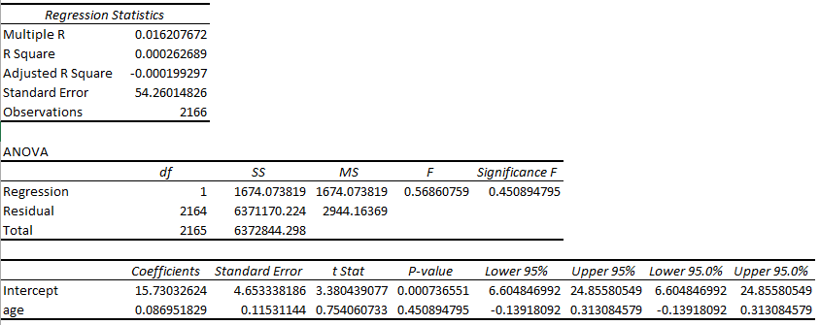

Graph 2
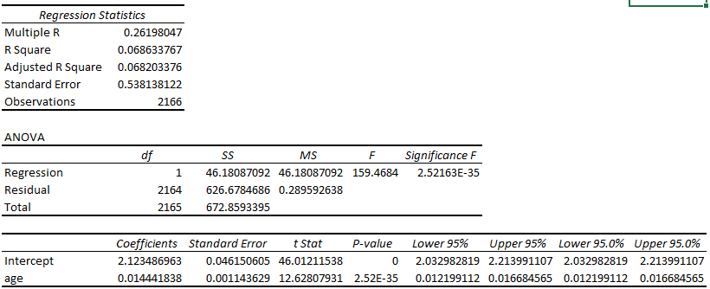
Question:
1. Is there a relationship between log (Wage) and Age? Compare your answer with graph (a) and identify the differences.
2. Explain how does using log (Wage) change the relationship between Wage and Age?

